SSURGO OnDemand Dynamic Spatial Interpretations Tool

Chad Ferguson & Jason Nemecek

Version: 09/24/2015

Highlights:

1. Process large extents rapidly. One stop shop for any number of Soil Survey Areas at once; State, Region for any/all interpretations or properties
2. No external tabular data is needed. It hacks data from Web Soil Survey
3. Extends the functionality of gSSURGO and the SSURGO Download Tools

Background:

1. The tools works with ArcGIS 10.1 or higher
2. Depending on internet connection and computer speed it can usually create a thematic map of a state in less than a minute (Statewide usually 20 s to 1 min)
3. Similar to Soil Data Viewer except the data is dynamic instead of static. No more using data that is several years old.
4. Grabs SSURGO tabular data from NRCS web services (over the web so the data is always the most recent)
5. Mimics Soil Data Viewer
6. Soil Data Viewer, MS Access, and external tabular data are not needed
7. Only layers required is Soil Survey Areas boundaries and most recent gSSURGO (gridded raster preferably)
8. Honors state specific interpretations uploaded to Web Soil Survey
9. Fast and easy to do large extents
10. Directions are included in the tool’s help section for each parameter

Tools:

1. Can generate Weighted Average properties Map based on certain depths.
2. These tools generate thematic interpretation maps in ArcMap by Soil Survey Area(s), States or Region for Dominant Condition, Dominant Component and Weighted Average
3. Currently Properties tool only supports Weighted Average aggregation

Future Additions or noted issues:

1. Adding a default symbology to the output thematic map if a join layer is specified.
2. Option for handling “Nulls” or “no data” in the properties. “No Data” would be if the row doesn’t exists in something like a miscellaneous map unit and no data there is a row but the column in “Null”
3. Adding Dominant Component Properties and other features similar to Soil Data Viewer

Required Layers:

* Soil Survey Areas representing your AOI (SAPOLYGON in a gSSURGO geodatabase. A layer with an AREASYMBOL field.)

Recommended Layers

* Soil Polygons (preferably the MapunitRaster layer in a gSSURGO geodatabase, MUPOLYGON does work but potentially takes a long time to draw. Any layer with an MUKEY field.)

Directions to Install the Interpretations Toolbox:

1. Unzip the zip file to a folder on the C drive



1. Open up ArcMap and click on the “ArcToolbox” icon

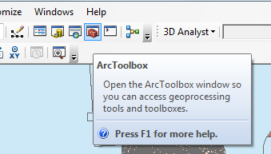

1. Using the mouse hover over the toolbox and “right click” and select “Add toolbox”

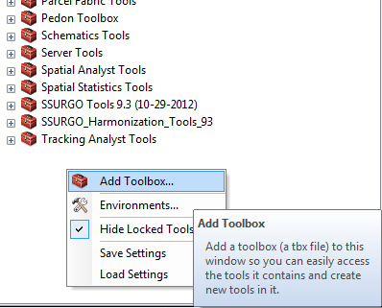

1. Browse to the folder where the tool was unzipped. Double click on subfolders and select the “NASIS Interpretation” toolbox and click on the “open” button

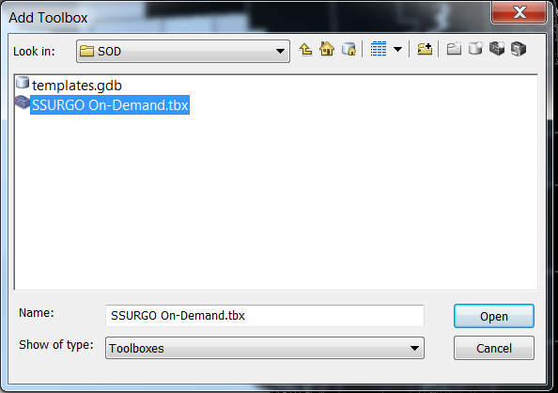

1. Right click again in the ArcToolbox and select “save settings” then “to default”

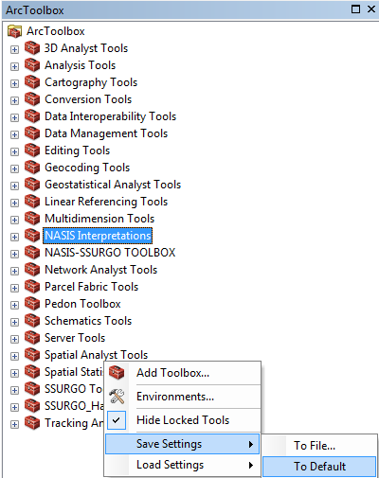

Interpretations Tool

**Dominant Condition**: The aggregation method "Dominant Condition" first groups like attribute values for the components in a map unit. For each group, percent composition is set to the sum of the percent composition of all components participating in that group. These groups now represent "conditions" rather than components. The attribute value associated with the group with the highest cumulative percent composition is returned. The example below the second 2 components would be the dominant condition.

|  |  |  |
| --- | --- | --- |
| Component | Percent | Class |
| Alpha | 40 | Very Limited |
| Beta | 30 | Slightly Limited |
| Theta | 30 | Slightly Limited |

**Dominant Component:** The aggregation method "Dominant Component" returns the attribute value associated with the component with the highest percent composition in the map unit. The result returned by this aggregation method may or may not represent the dominant condition throughout the map unit.

**Weighted Average:** The aggregation method "Weighted Average" computes a weighted average value for all components in the map unit. Percent composition is the weighting factor. The result returned by this aggregation method represents a weighted average value of the corresponding set classes for the map unit.

|  |  |  |  |
| --- | --- | --- | --- |
| **Fuzzy Value** | **Assigned Value** | **Limitation Rating Class** | **Suitability Rating Class** |
| 0 | 0 | Not Limited | Not Suited |
| > 0.001 and <=0.333 | 1 | Slightly Limited | Poorly Suited |
| > 0.334 and <=0.666 | 2 | Somewhat Limited | Moderately Suited |
| > 0.667 and <=0.999 | 3 | Moderately Limited | Moderately Well Suited |
| 1 | 4 | Very Limited | Well Suited |
| — | 99 | Null | Null |
| — | 50 | Water | Water |

Properties Tool

**Weighted Average:** The aggregation method “Weighted Average” computes a weighted average value for all components in the map unit. Percent composition is the weighting factor.

The result returned by this aggregation method represents a weighted average value of the corresponding attribute throughout the map unit.

 Horizon Aggregation “Aggregation” is the term we use to describe the process of reducing a set of component values down to a single value to represent the corresponding map unit as a whole. When we say “aggregation”, without any qualifiers, we mean “component aggregation”. Horizon aggregation is a similar concept.

When horizon aggregation is performed, a weighted average of the corresponding soil property is computed, where layer thickness is the weighting factor. The term layer thickness is appropriate because when a depth range is specified, that depth range may include only part of some soil horizons. Let’s look at the following example.

A component has three horizons. The soil attribute in question is “Percent Clay”. The depth qualification is specified as “Depth Range”, 10 to 20 cm.

|  |  |  |  |  |  |  |  |  |
| --- | --- | --- | --- | --- | --- | --- | --- | --- |
| **Horizon** | **Top Depth** | **Bottom Depth** | **Calculated** | **Adjusted top** | **Adjusted bottom** | **Thickness** | **Clay** | **Weighted Factor** |
| **Ap** | 0 | 10 | No | 10 | 10 | 0 | 50 | 0 |
| **Bt1** | 10 | 18 | Yes | 10 | 18 | 8 | 45.5 | 36.4 |
| **2Bt2-Bt7** | 18 | 127 | Yes | 18 | 20 | 2 | 20 | 4 |
|  |  |  |  |  | Sum Thickness | 10 | Sum Factor | 40.4 |

So horizon aggregation needs to be performed because all of the first two horizons and part of the third horizon are included. The percent clay value returned for this component would be computed as follows:

(--/--)*-- + (8/10)*45.5 + (2/10)*20 = 40.4

 The first horizon contributes 0% of the total depth (0/0), the second horizon contributes 80% of the total depth (8/10), and the last horizon contributes 20% of the total depth (2/10).

When computed all the components the same concept is calculated using the component percent and that component properties computed factor.

Source

Soil Survey Staff, Natural Resources Conservation Service, United States Department of Agriculture. Soil Data Viewer User Guide. Available online at http://www.nrcs.usda.gov/Internet/FSE_DOCUMENTS/nrcs142p2_052432.pdf. Accessed [09/24/2015].